Documentation and Protocols Homework Packet

This homework packet is designed to help you practice evaluating documentation and protocols (SOPs), which you will need to do when auditing on-farm.

Please bring your answers to the PAACO training session and be prepared to discuss as part of the first farm we review, Valley Dairy.

Evaluate the 4 provided Documentation and Protocols and determine if they acceptable or not based on the PAACO Example Dairy Audit before your PAACO training session begins. Explain why or why not.

- Signed Cattle Care Agreement
- Euthanasia
- Disbudding & Other Painful Procedures
- Fitness for Transport

- Cow care agreement

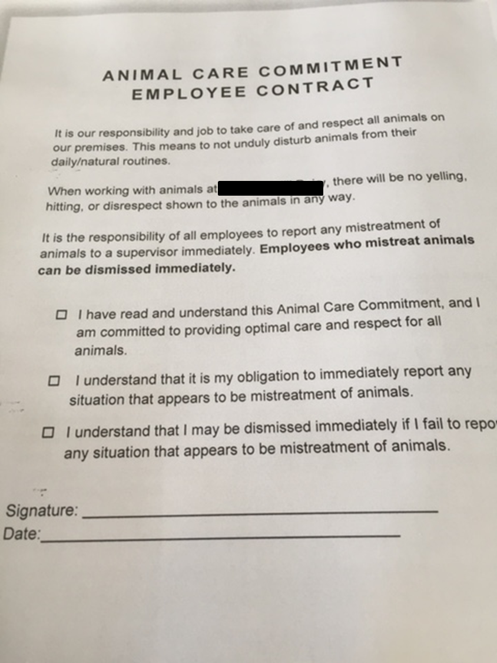

Acceptable or not? Why?:

- Euthanasia
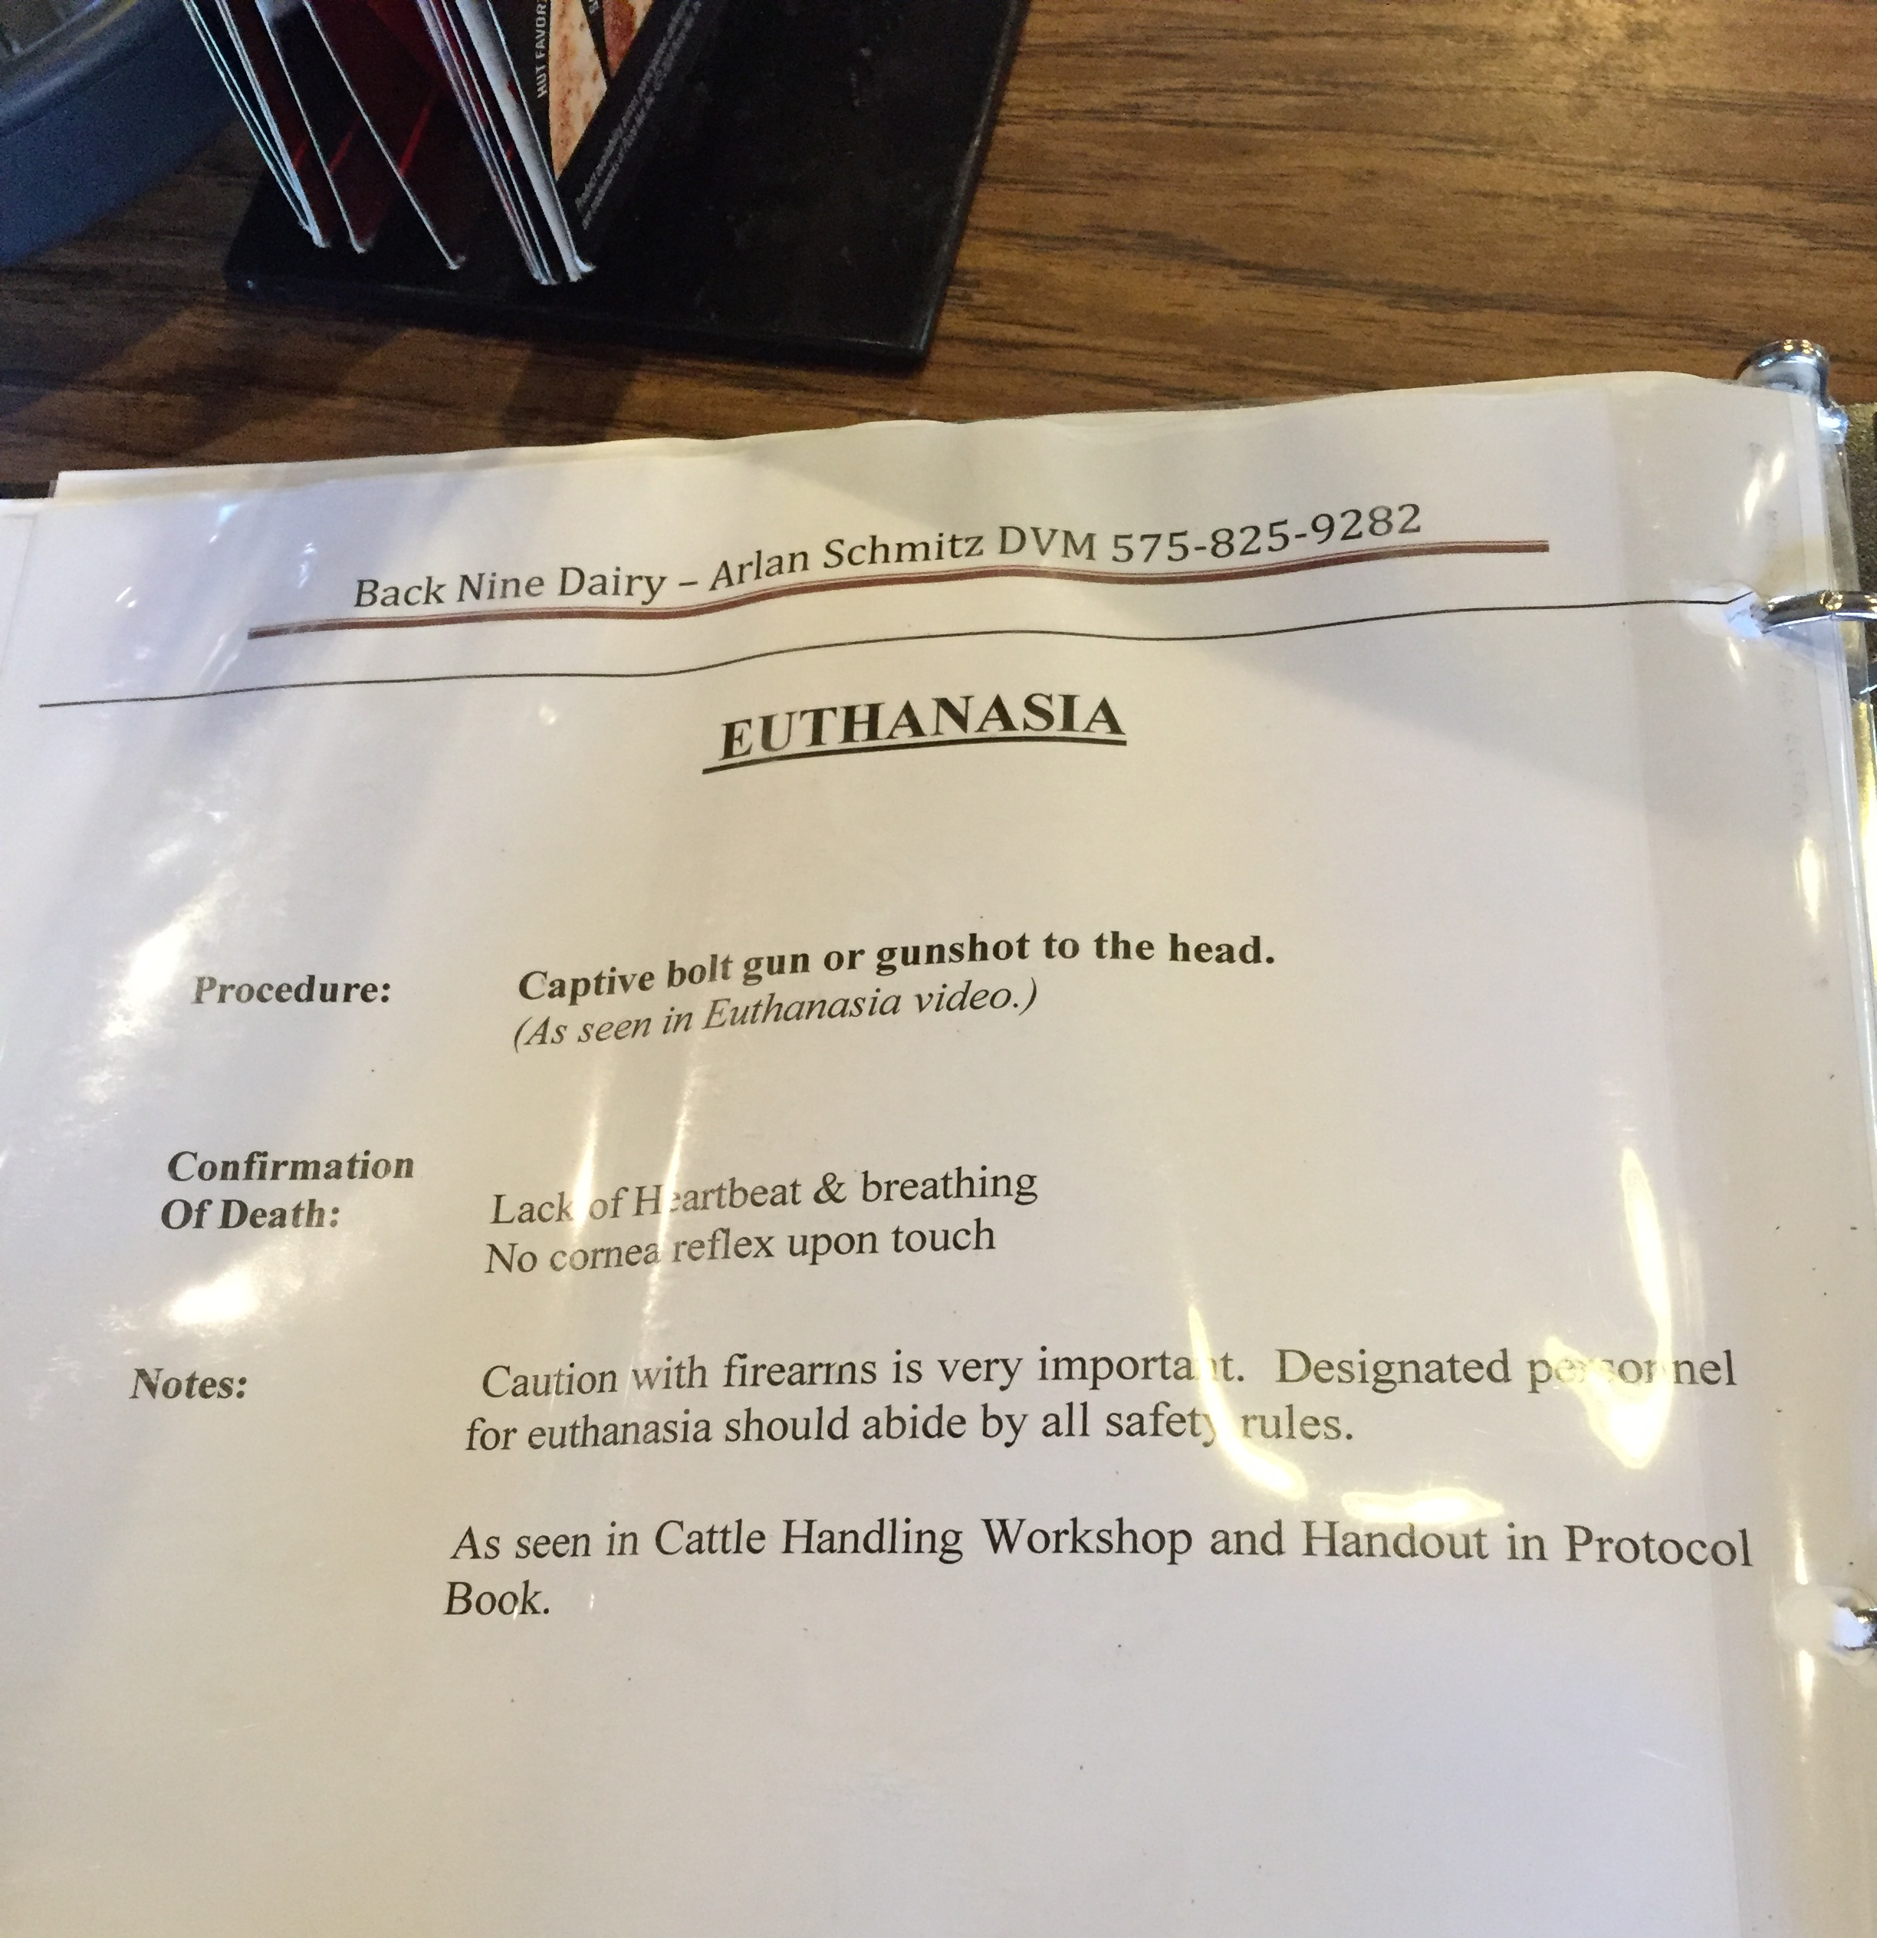

Acceptable or not? Why?:

- Painful procedures
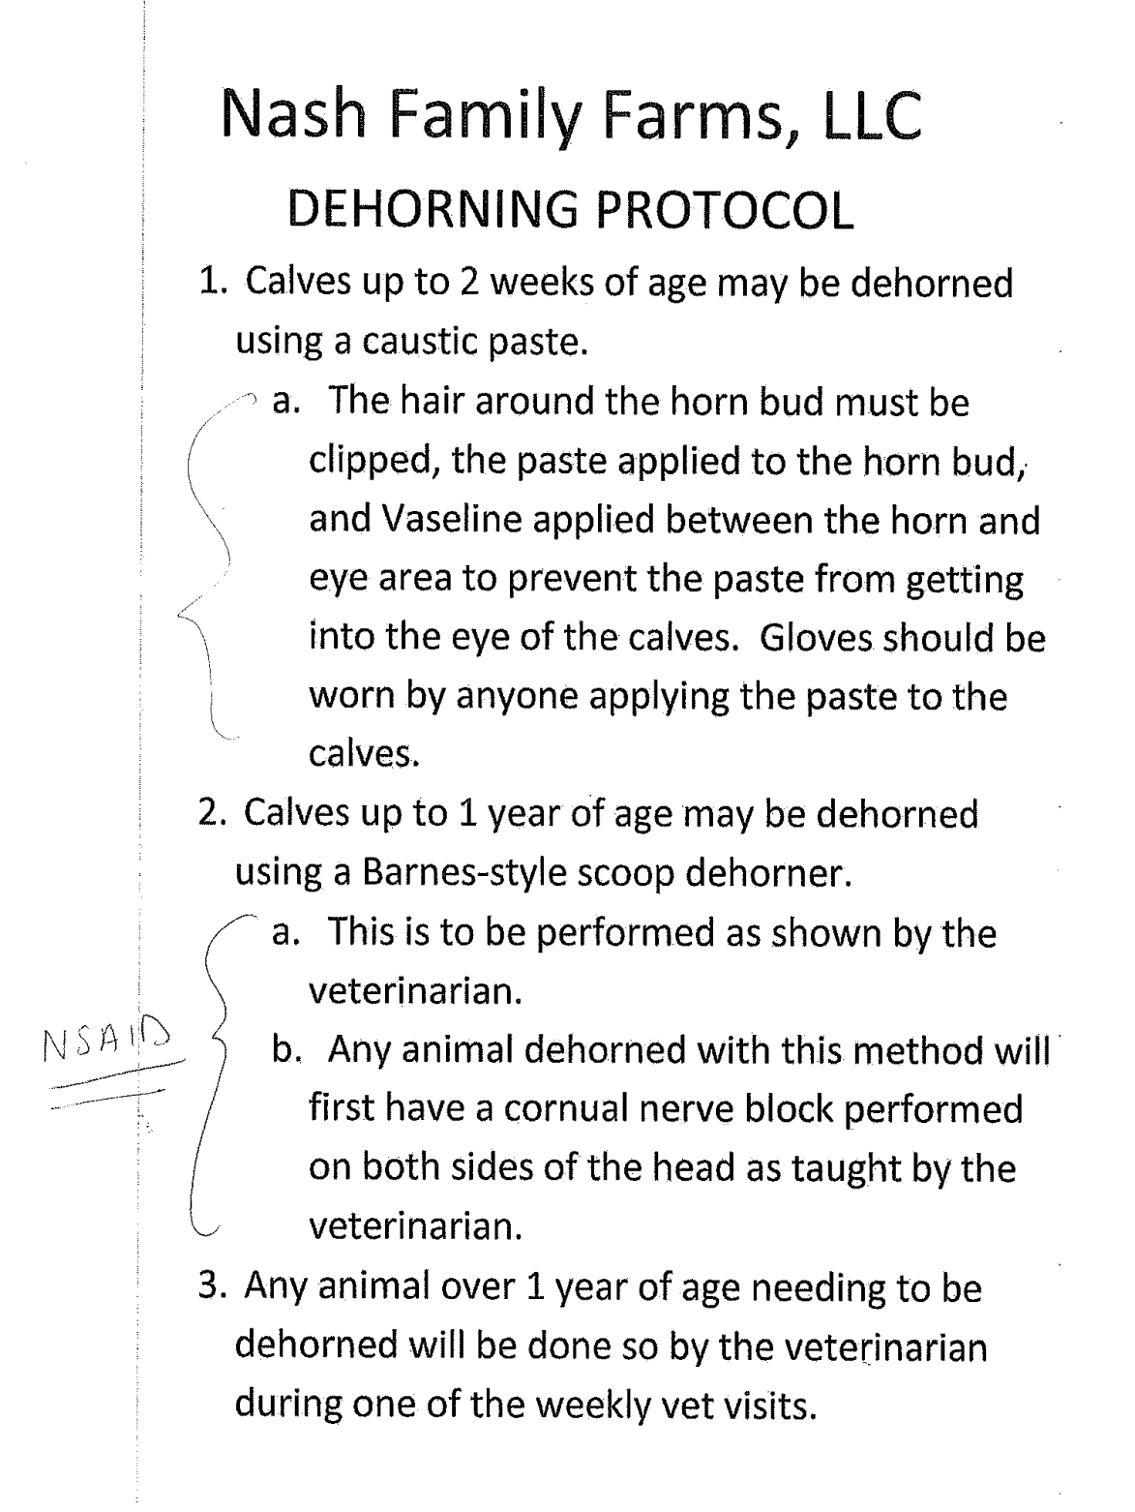
Acceptable or not? Why?:

- Fitness for transport
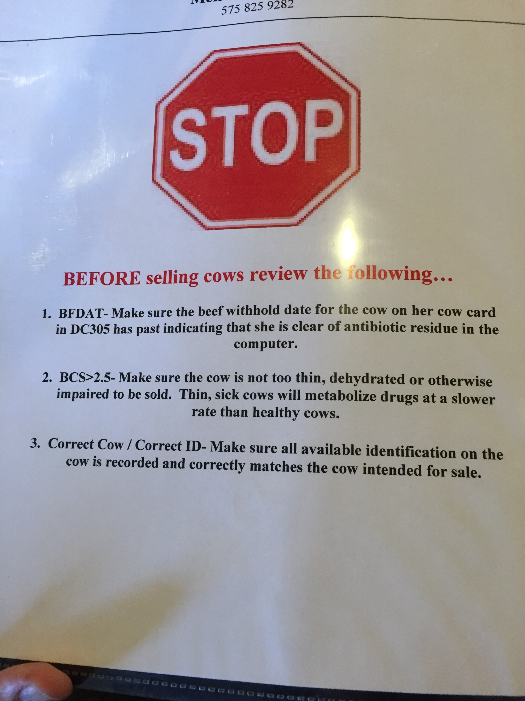

Acceptable or not? Why?:

